Custom bootloader documentation

FBL_vJumpToUserApplication
Parameters: void
Return type: void
Description:
The function set the MSP value using the CMSIS _set_MSP() function as the value from flash sector 2 base address (0x0800_8000) – 0x2000_0468. Then the value from the reset handler address (0x0800_8004) is read and stored in the ulResetHandlerAddr. Then the function jumps to that value.
The vector table is shifted to the new base address.
SCB->VTOR = FLASH_BASE | VECT_TAB_OFFSET; /* Vector Table Relocation in Internal FLASH */
Other informations:
After a MCU reset the PC (program counter) of the processor is loaded with value 0x00000000. The processor reads the value at memory location at memory location 0x0000_0000 and stores in in the MSP (Main stack pointer). After that the value 0x0000_0004 is loaded in PC, which is the address of the reset handler. The PC jumps to the reset handler. The reset handler is an assmelby routine which calls the main function of the application.
Memory aliasing: map differentaddresses into different memory addresses
The base address of the user flash in SMT32F4 is 0x0800_0000 and represents the MSP. The address 0x0000_0000 is mapped to 0x0800_0000.
Boot configuration:
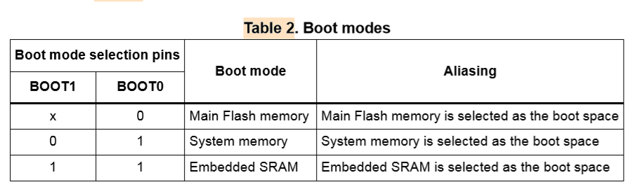
FBL_ucVerifyCRC
Parameters: uint8_t *pucData, uint32_t ulLength,uint32_t ulCRCHost
Return type: uint8
Description: computes the CRC using 8 byte polynome 0x04C11DB7 and compares it with the received CRC.

